**Homework 4 - Structure From Motion**

**Ron Benchetrit – 312167554**

**Doron Hanuka – 315824318**

**Part 1 - Sparse Reconstruction**

* 1. **Eight Point Algorithm:**

Visualization of some epipolar lines:

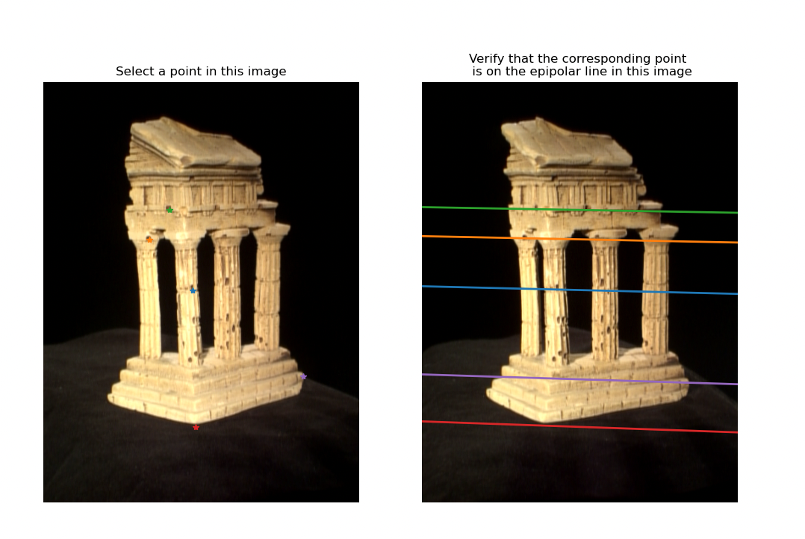

Resulted fundamental matrix:

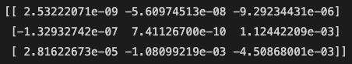

* 1. **Epipolar correspondences:**

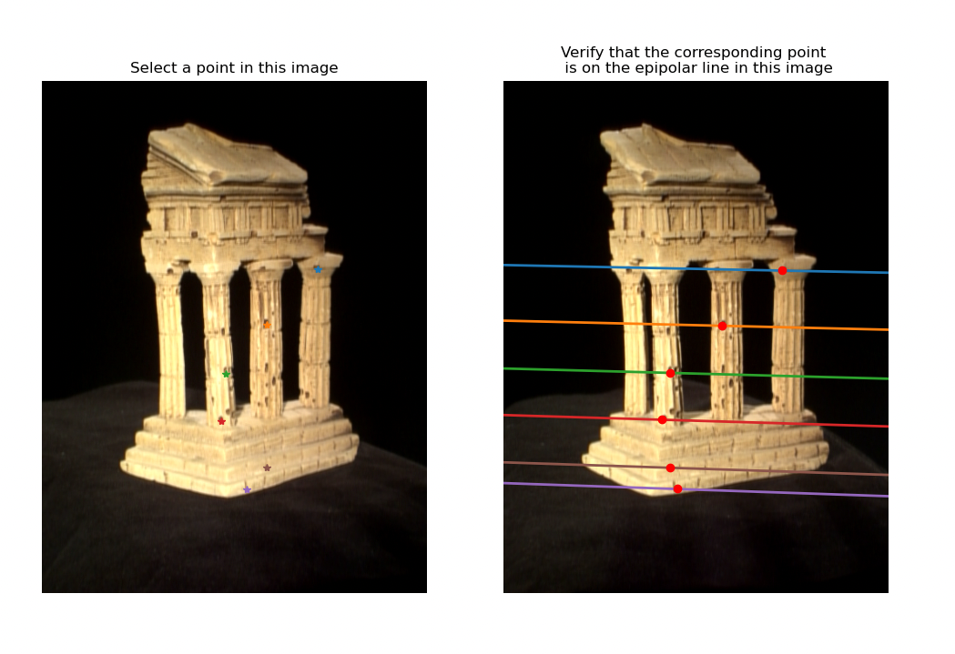Except the brown point, all correspondences are correct.

We generated 50 candidates along the epipolar line.

We decided to use a window of size 21 (10 in each direction around the candidate pixel) and compare the windows using the L1 norm.

Because we just use the L1 norm the matching is sensitive to orientation, scales and noise.

It would be better to use a descriptor such as SIFT or ORB but for case the L1 norm suffices and works well most of the time.

* 1. **Essential Matrix:**

Resulted E:

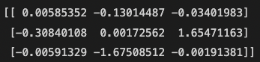

* 1. **Triangulation:**

We found the right extristics matix by going over all the candidates, triangulating the points, and see for which extrinstics the depth is positive both in camera 1 frame and in camera 2 frame.

We got the following re-projection errors in pixels units.



* 1. **Putting It All Together:**

Transformations parametrs:

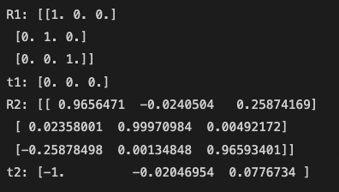

Final reconstruction:

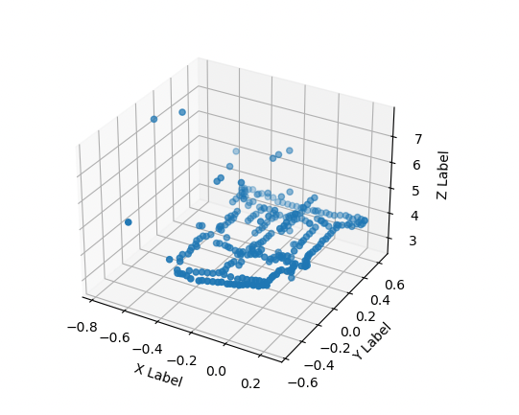

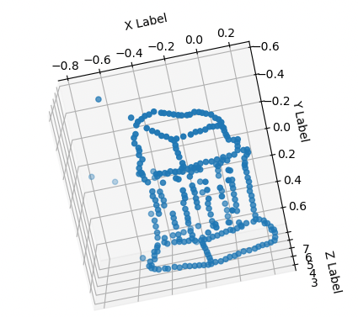

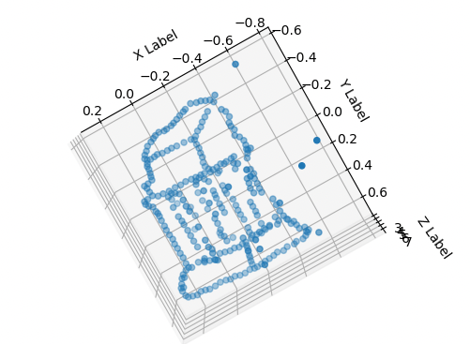

2)

a)  
output script :

Reprojection Error with clean 2D points: 8.690237512664843e-10

Pose Error with clean 2D points: 5.8551403938435676e-12

Reprojection Error with noisy 2D points: 10.544655781626583

Pose Error with noisy 2D points: 1.2033535275144753

Error received for noisy points are very large compared to points that are not noisy.

b)  
output script:  
Intrinsic Error with clean 2D points: 1.6570198071374701e-12

Rotation Error with clean 2D points: 6.45896163337992e-13

Translation Error with clean 2D points: 8.193891360111391e-13

Intrinsic Error with noisy 2D points: 0.735153584152943

Rotation Error with noisy 2D points: 3.4621773752249583

Translation Error with noisy 2D points: 2.120813189782449

Error received on clean points is very small, largest error are in the intrinsic matrix.  
  
c) the image:  
  
